BCSE302L- Database Systems
 |  | Subject Code | BCSE302L
 |  | Subject Name | Database Systems
Programme | BTech CSE | DA-2
Date | 24/03/2026

School: SCOPE
Project Title: Inventory & Supplier Management System
Course Code: BCSE302L
Course Title: Database Management Systems
Class Number: CH2025260501233
Semester: Winter 2025-26
Slot: A1+TA1
Team members: Abhinav Bhuniya, 24BCE1731
Aveek Sanyal, 24BCE1081
Gaurav Satyedev, 24BCE1828
Course Faculty: Dr. L.M. Jenila Livingston

2. Objective
The objective of this project is to implement the Inventory & Supplier Management System using SQL. The system aims to manage product details, supplier information, stock levels, purchase orders, and payment records efficiently using a relational database.

3. Normalization
Unnormalized Form (UNF)
A single table:
Order_ID, Product_Name, Supplier_Name, Supplier_Phone, Quantity
Problems:
- Data redundancy
- Repeated supplier & product details

First Normal Form (1NF)
- Remove repeating groups
- Atomic values only
Order_ID, Product_Name, Supplier_Name, Supplier_Phone, Quantity
(still redundant)

Second Normal Form (2NF)
- Remove partial dependency
Split into:
PRODUCT(Product_ID, Product_Name, Unit_Price)
SUPPLIER(Supplier_ID, Supplier_Name, Phone)
PURCHASE_ORDER(Order_ID, Product_ID, Supplier_ID, Quantity)

Third Normal Form (3NF)
- Remove transitive dependency
Final tables:
PRODUCT(Product_ID, Product_Name, Category, Unit_Price)
SUPPLIER(Supplier_ID, Supplier_Name, Phone, Email)
PURCHASE_ORDER(Order_ID, Order_Date, Quantity, Supplier_ID, Product_ID)
STOCK(Stock_ID, Product_ID, Available_Quantity, Last_Updated)
PAYMENT(Payment_ID, Order_ID, Amount, Payment_Date, Payment_Mode)

4. Final Relational Schema
- Product(Product_ID, Product_Name, Category, Unit_Price)
- Supplier(Supplier_ID, Supplier_Name, Phone, Email)
- Purchase_Order(Order_ID, Order_Date, Quantity, Supplier_ID, Product_ID)
- Stock(Stock_ID, Product_ID, Available_Quantity, Last_Updated)
- Payment(Payment_ID, Order_ID, Amount, Payment_Date, Payment_Mode)

5. SQL Implementation
Table Creation
CREATE TABLE Product (...);
CREATE TABLE Supplier (...);
CREATE TABLE Purchase_Order (...);
CREATE TABLE Stock (...);
CREATE TABLE Payment (...);

Insert Operations
INSERT INTO Product VALUES (...);
INSERT INTO Supplier VALUES (...);

Queries
Select
SELECT * FROM Product;
Join (Important)
SELECT p.Product_Name, s.Supplier_Name, po.Quantity
FROM Purchase_Order po
JOIN Product p ON po.Product_ID = p.Product_ID
JOIN Supplier s ON po.Supplier_ID = s.Supplier_ID;
Update
UPDATE Stock
SET Available_Quantity = Available_Quantity - 5
WHERE Product_ID = 1;
Delete
DELETE FROM Payment WHERE Payment_ID = 2;

6. Output Screenshots
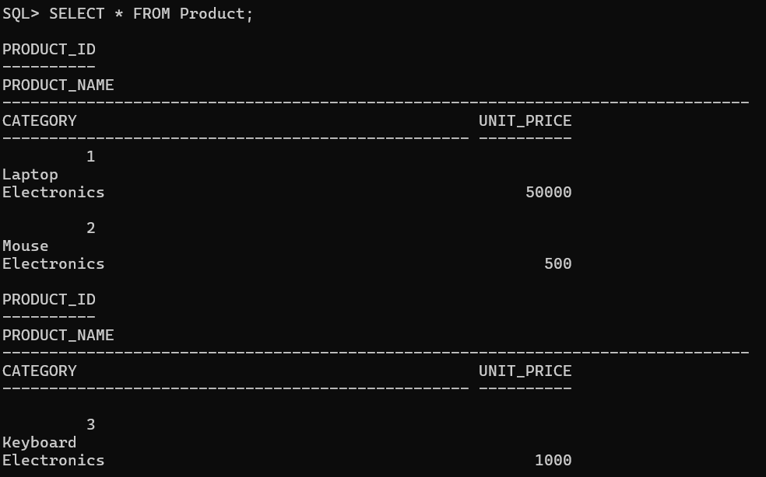
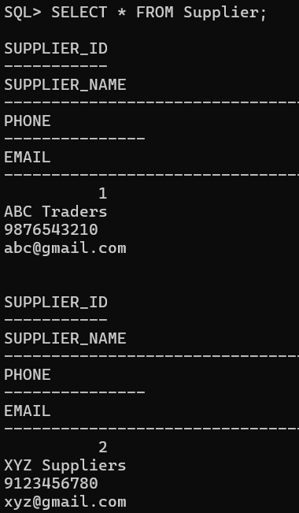
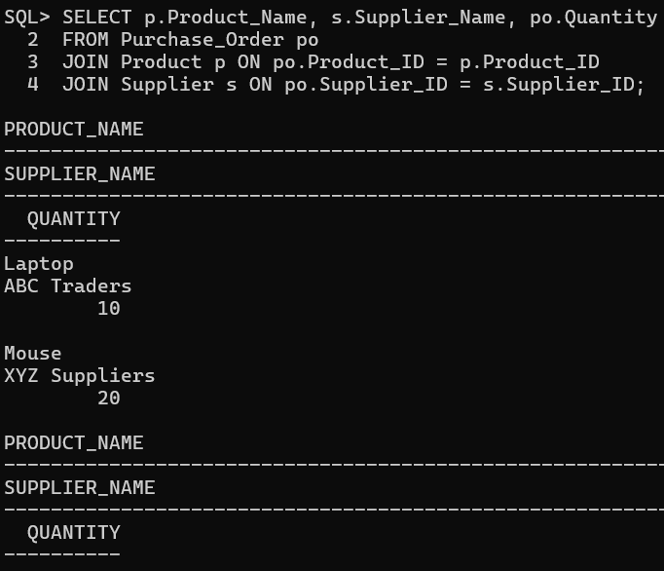
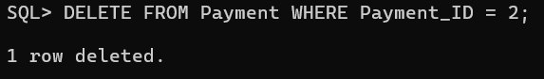

7. Backend to Frontend Conversion
The database operates at the backend where SQL queries are executed. The data is retrieved and processed by the backend server and then displayed on the frontend interface using applications or web technologies.
Flow:
Database → SQL Queries → Backend → Frontend UI

8. Conclusion
The Inventory & Supplier Management System successfully demonstrates the use of relational databases for efficient data management. The system ensures data consistency, reduces redundancy, and provides efficient querying using SQL operations.

